Trần Thị Ngọc Thủy
2131200044
Question 3. Create Expo CLI apps
Create project:
Open file ‘App.js
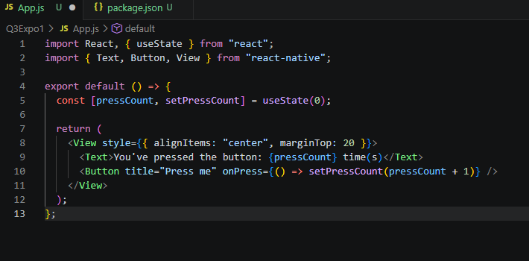
Run Expo CLI app
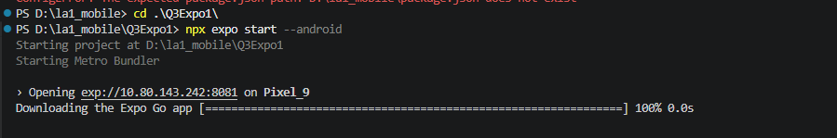
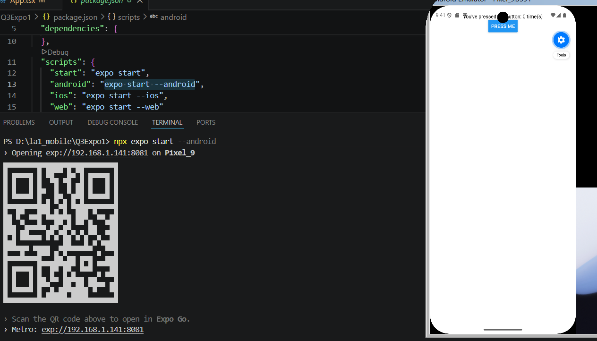
Another way to run the Expo app. Go to: https://snack.expo.dev/ You can view results with Web/Android/iOS interface
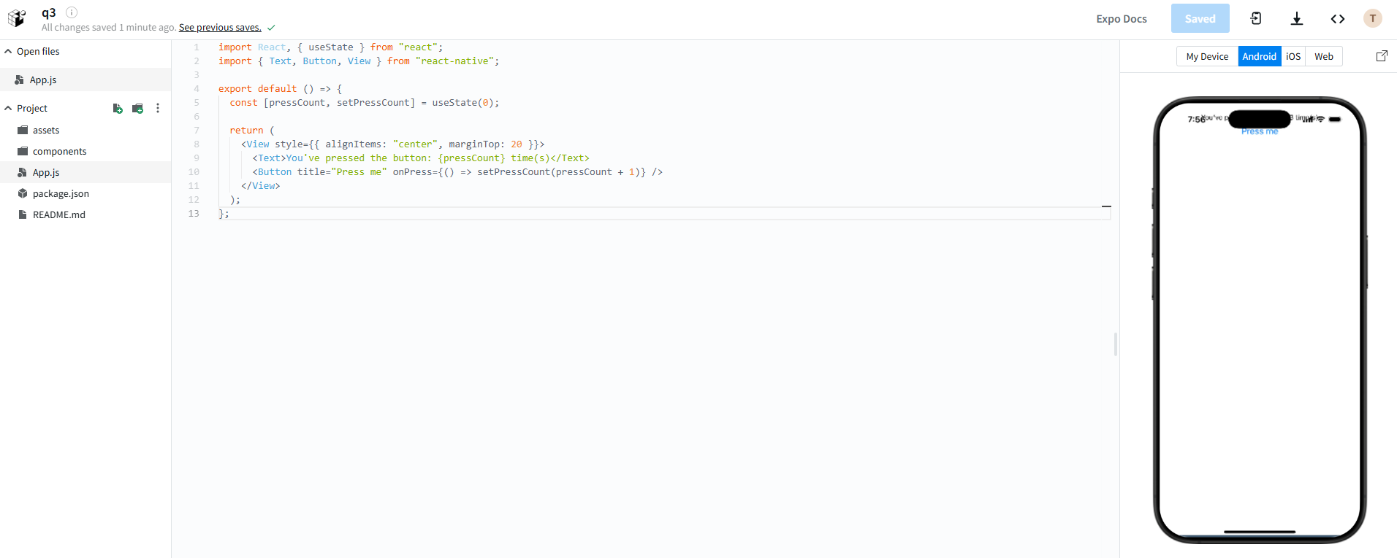
Question 4. Create React native CLI apps
- Create project with React native CLI:
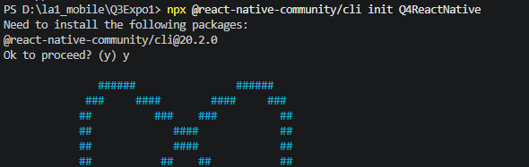

- "style.js" file
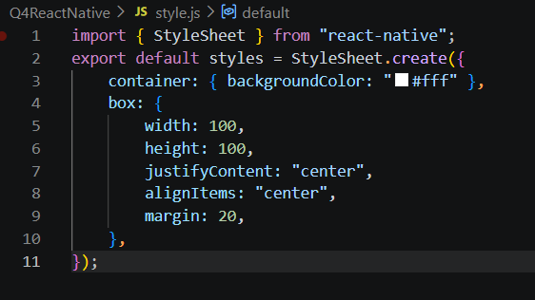
- "Data.js" file
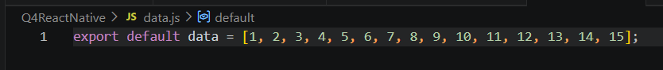
- "Square.js" file
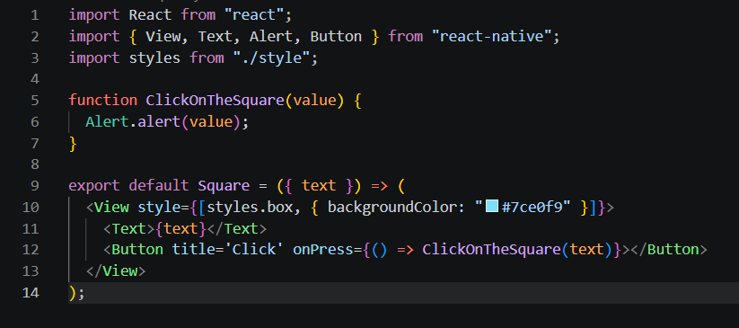
- "App.tsx" file
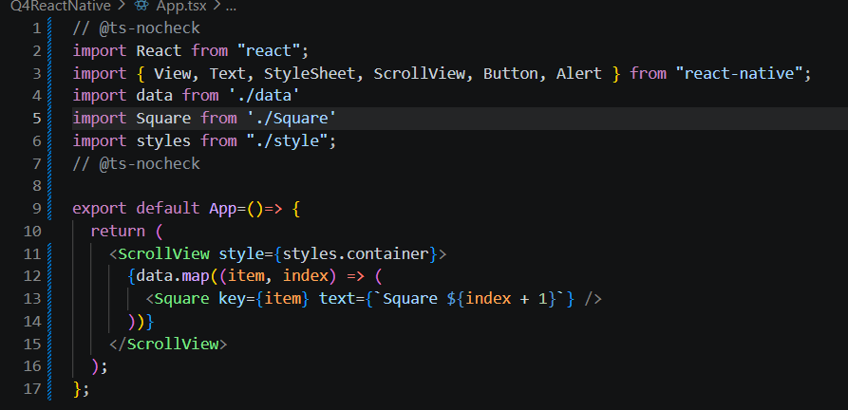
- Run React native CLI app
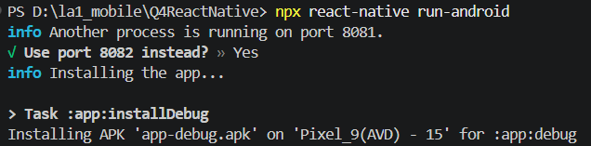

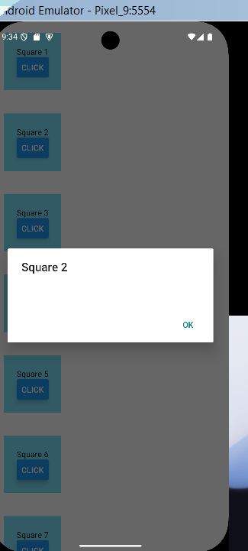
Question 5. Publishing
Save 2 * files. AAB and *. APK to folder
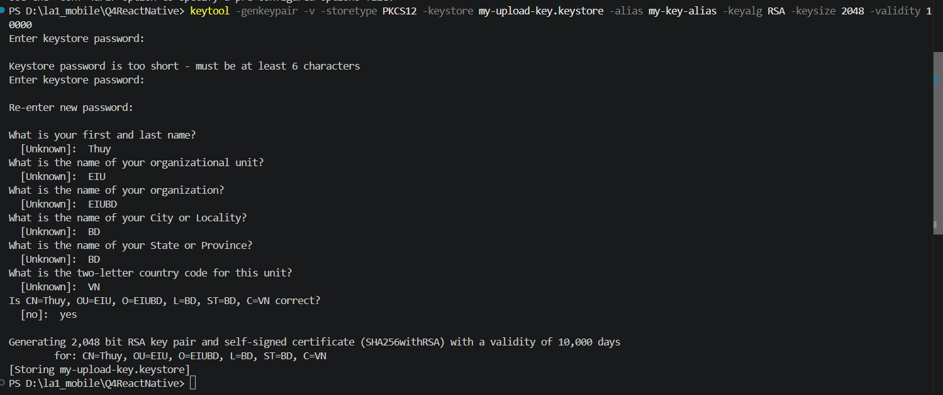
Place the my-upload-key.keystore file under the android/app directory in your project folder
Edit the file ~/.gradle/gradle.properties or android/gradle.properties, and add the following (replace ***** with the correct keystore password, alias and key password)
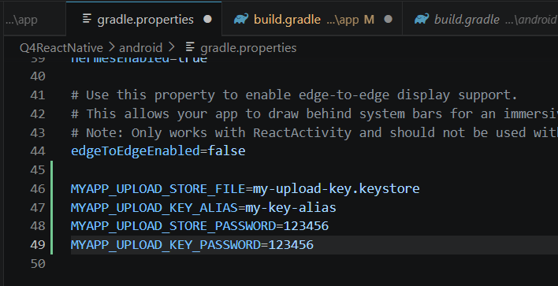
Edit the file android/app/build.gradle in your project folder, and add the signing config
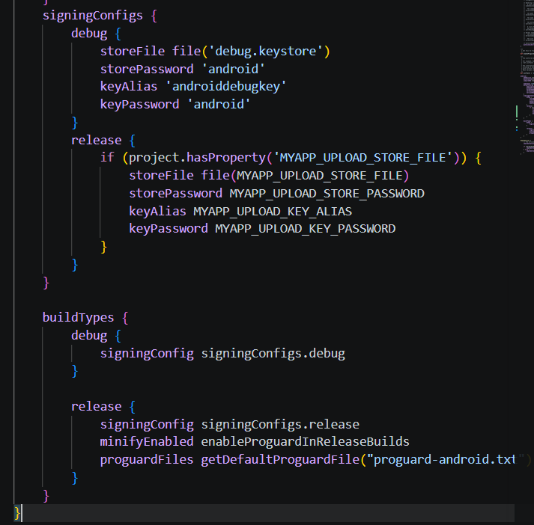
- GeneratingthereleaseAAB(Supportfiledeployedtogoogleplay
- Build React native App to apk file
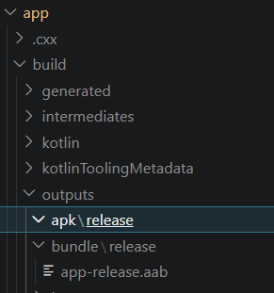
Question 6 Build apps with props and state
